1. Which are the top three variables in your model which contribute most towards the probability of a lead getting converted?

Ans: - Based on the final model consisting of 10 variables the top 3 variables

contributing most towards the probability of a lead getting converted are

* 1. Lead Origin_Lead Add Form (From Lead Origin variable)

– having a coefficient equal to 3.3372

* 1. current_occupation_Working Professional (From current_occupation variable)

– having a coefficient equal to 2.7915

* 1. Lead Source_Welingak Website (From Lead Source Variable)

– having a coefficient equal to 2.6610

1. What are the top 3 categorical/dummy variables in the model which should be focused the most on in order to increase the probability of lead conversion?

Ans: - The top 3 categorical/dummy variables in the model which should be focused the

most on in order to increase the probability of lead conversion are

* 1. Lead Origin_Lead Add Form – having a coefficient equal to 3.3372
  2. current_occupation_Working Professional – having a coefficient equal to 2.7915
  3. Lead Source_Welingak Website – having a coefficient equal to 2.6610

1. X Education has a period of 2 months every year during which they hire some interns. The sales team, in particular, has around 10 interns allotted to them. So during this phase, they wish to make the lead conversion more aggressive. So they want almost all of the potential leads (i.e. the customers who have been predicted as 1 by the model) to be converted and hence, want to make phone calls to as much of such people as possible. Suggest a good strategy they should employ at this stage.

Ans: - The optimal cutoff of final model is 0.3 as seen in picture below

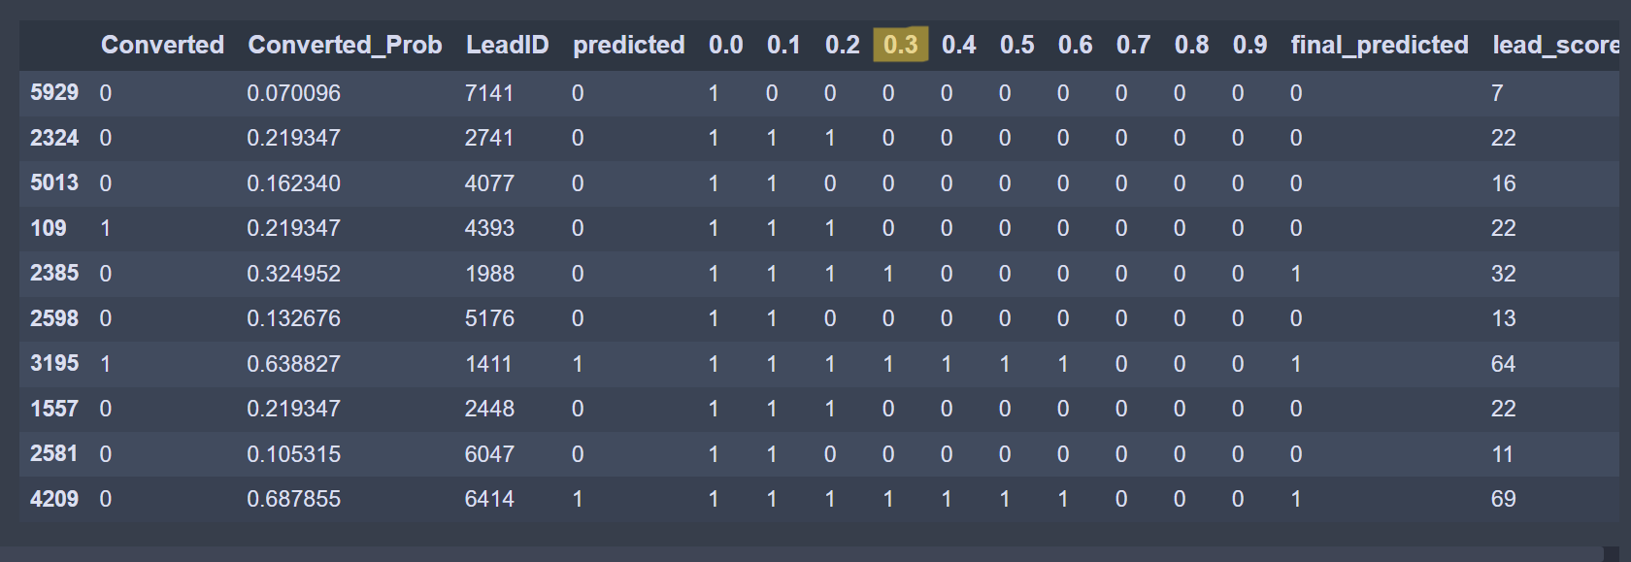

1. For all potential leads to get converted the sales team can adopt the strategy of connecting with all the leads having a lead_score above 30 and educate them about the product maintain a constant communication.
2. If all customers having a lead_score above 30 have been targeted then the sales team can also target customers with lead_score of 20 and above as these customers can also convert

1. Similarly, at times, the company reaches its target for a quarter before the deadline. During this time, the company wants the sales team to focus on some new work as well. So during this time, the company’s aim is to not make phone calls unless it’s extremely necessary, i.e. they want to minimize the rate of useless phone calls. Suggest a strategy they should employ at this stage.

Ans: - 1. A strategy to minimize the rate of useless phone calls can be to choose only the

Leads having a lead_score above 60 or 70

2. If a customer has a lead score lower than 60 or 70 but he/she has a combination

of attributes which are, visited the website multiple times or spent more than 10

minutes on the website or is a working professional or has Lead Source as

‘Welingak Website’ or has Lead Origin as ‘Lead Add Form’ or has come on the

website through someone’s recommendation, then they are most likely to convert

and such customers can also be targeted.